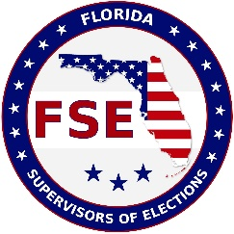

PRESS RELEASE
November 1, 2019

Florida Supervisors of Elections to Offer Scholarship Opportunities
The Florida Supervisors of Elections is proud to once again offer scholarship opportunities to students from around the state. Three scholarships in the amount of $1,200 each will be awarded in 2020 with the winning students to be announced and recognized at the FSE Summer Conference to be held next May.
Applicants must be registered voters in Florida who have lived in the state for at least the preceding two years and have maintained at least a “C” average. Applicants must have been accepted or enrolled as a full-time student in a senior college or university in Florida and completed two years of junior college or undergraduate work. Students who apply must be either a Political Science, Public/Business Administration, or Journalism/Mass Communication major.
For the full list of requirements and for more information applicants are encouraged to reach out to the Supervisor of Elections office from their county of residence.
“It has been a wonderful and longstanding tradition for the Florida Supervisors of Elections to award scholarships to worthy students from around the state” said current FSE President Tammy Jones of Levy County. “We are again excited to provide these opportunities that could lead to productive careers in the public service arena.”
The three scholarships are presented in memory of former Supervisors of Elections Dorothy Ruggles of Pinellas County, Joe Oldmixon of Escambia County, and Jimmy Whitehouse of Highlands County.

