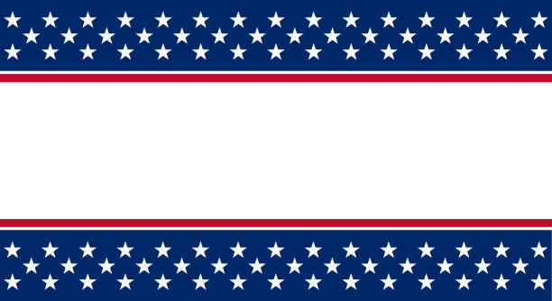
Secure the Vote
Legislative Updates

We know there is a lot of buzz in the media regarding some changes that have been made in our legislation. We would like to go over some things that are currently affecting you. The voters that enjoy voting by mail still have the same options as before: mail the ballot back to the SOE office, take the ballot to an early voting site and drop it in the secure drop box, or bring it to the SOE office in Sebring and place it in the secure drop box. However, requesting a ballot for future elections has an added step. At the bottom of the signed envelope, continue checking the box stating you wish to keep receiving vote by mail ballots. Before you seal the ballot in the envelope, take notice of the stamp on the flap. Please be sure to fill in your full driver’s license number OR the last four of your social security number. Without this information, we will not be able to continue a future request for vote by mail. The standing request is for only one cycle, so be sure to fill out this information.

2022 DATES and Deadlines

Municipal Elections
Lake Placid Town Council: April 5th

Primary Election
Deadline to register to vote or change your party: July 25th
Early Voting: August 11th – August 20th *
Election Day: August 23rd

General Election
Deadline to register to vote or change your party: October 11th
Early Voting: October 27th – November 5th *
Election Day: November 8th
* Subject to change

By: Cortni Mays, Deputy SOE
The Highlands County SOE Newsletter
A message from your Supervisor:
Thank you for the opportunity to serve you. It is an honor and privilege held with the upmost confidence. If you have any questions, please call us. We are your trusted source for election information! I approve and endorse this newsletter. Karen C. Healy

Our Vision
Our vision is to promote and preserve the sacred fundamental right to vote by identifying and applying innovative strategies and technologies to ensure the freedom to vote with confidence and fairness in the election process.
OUR MISSION
Uphold the Constitution of the United States to include state laws and maintain public confidence by registering eligible voters and conducting honest and fair elections, in an accurate, efficient, and secure manner.
OUR PROMISE
We promise to maintain integrity and strong ethical principles in the community by conducting transparent elections in accordance with professional standards.

Karen Healy, Supervisor of Elections

Highlands County Supervisor of Elections is looking for qualified registered voters to serve and earn pay by working at the polls for our upcoming Primary and General Elections of 2022. You must be a registered voter in Highlands County, have reliable transportation, and be able to sit or stand for long periods of time. An average day can be as long as 14 hours. In addition, one must be able to work with the public in a courteous, patient, and efficient manner and able to read, write and speak English. Bilingual workers are also needed as well. There are multiple jobs we need to fill such as Clerk and Assistant Clerk, Deputy, Systems Specialist, EViD Operator, and Ballot Distributor. Our Elections Worker Manager, Debbie Schoonover, is initiating interviews now and would love to sit down with you. Give her a call at 863-402-7032.
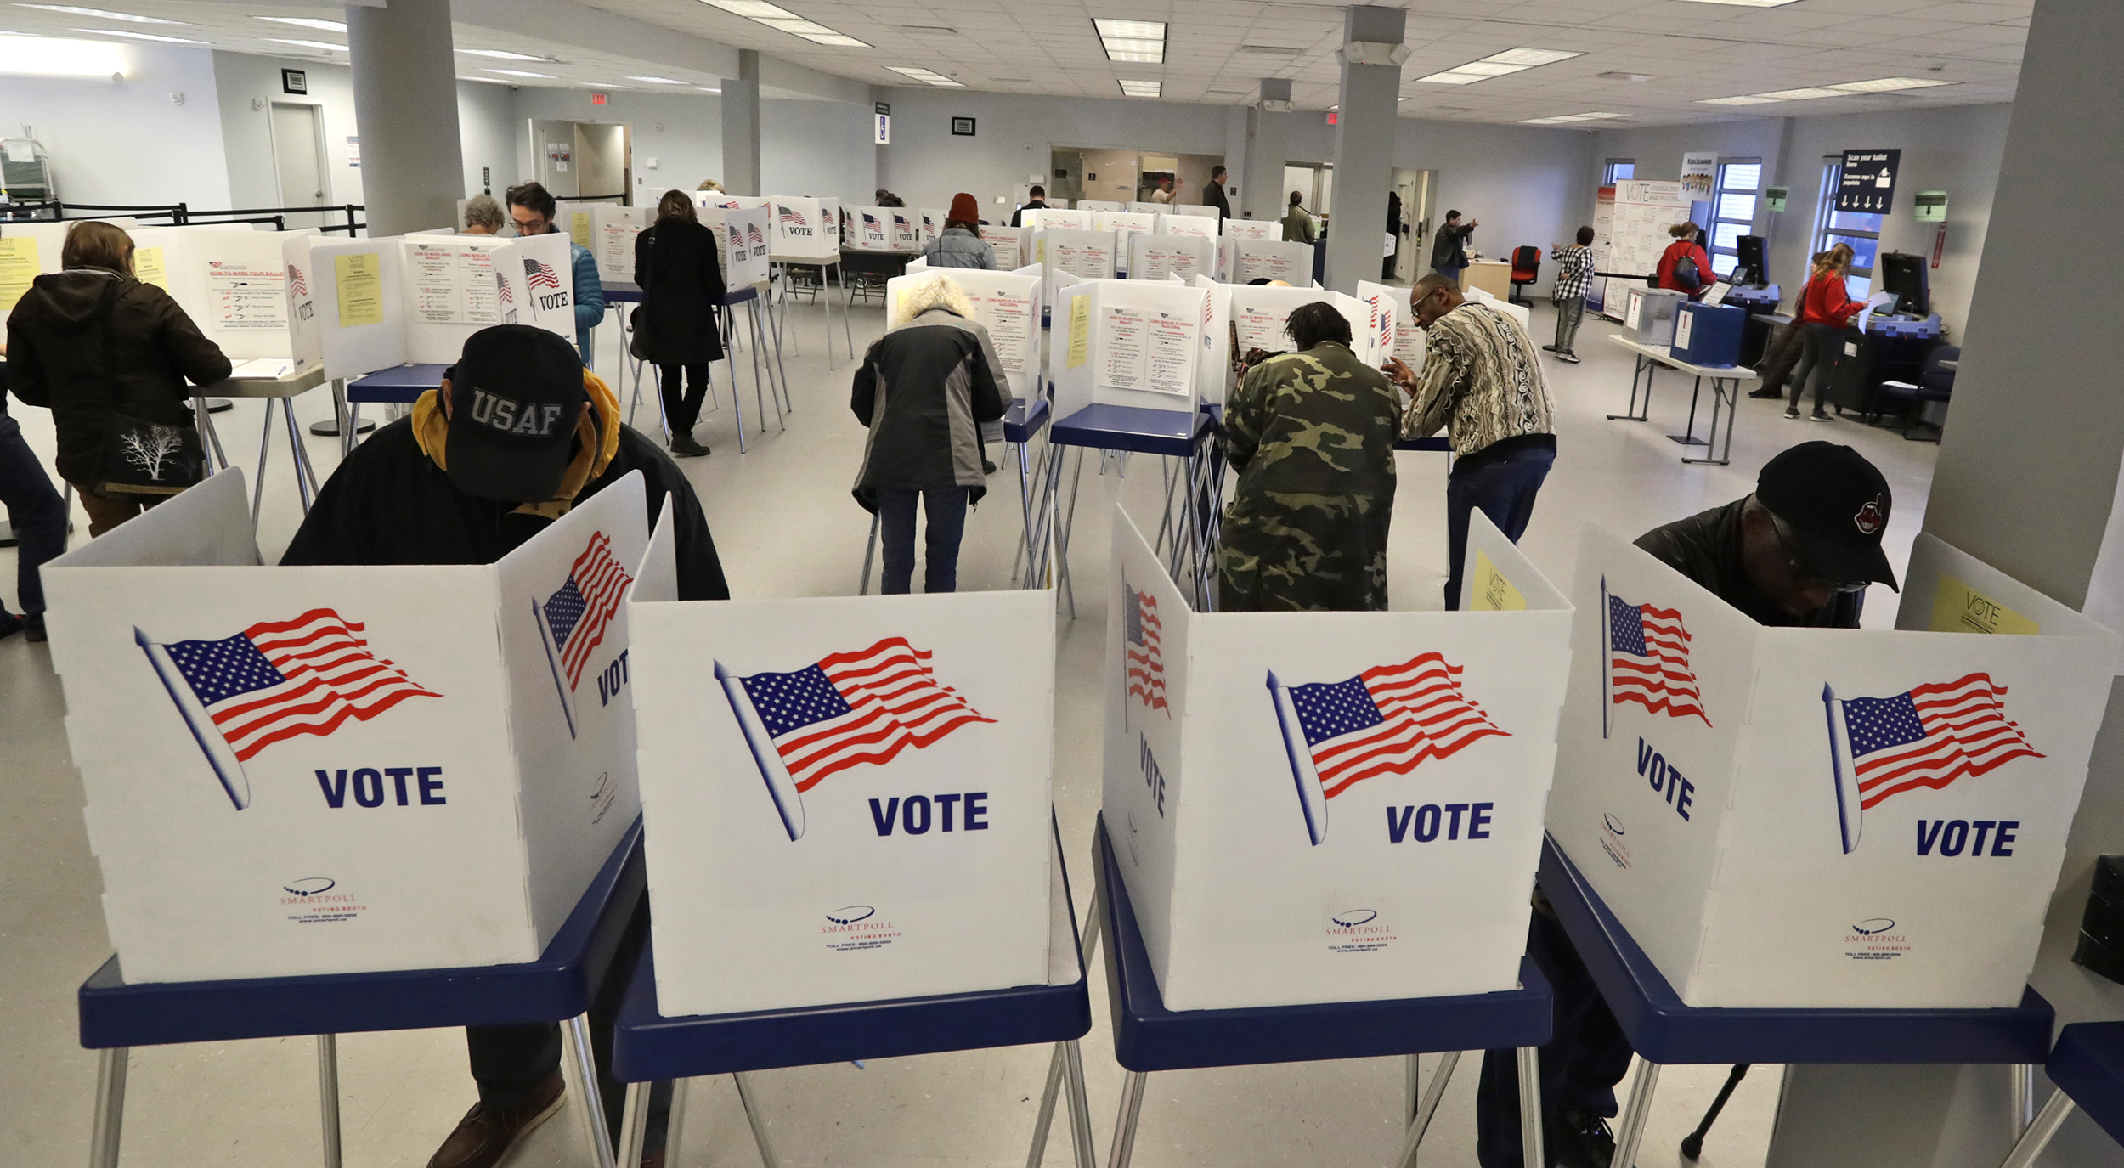

Florida Supervisor of
Elections Scholarship

If you are thinking about attending college in Florida, the Supervisor of Elections can help you out financially on the journey. We will send one finalist application to the Scholarship Committee along with a letter of recommendation. The Committee will select four winners who will receive $1,200 each. The best part is, even if you win, you can apply again the following year! Applicants must be a Political Science, Public or Business Administration, Journalism, or Mass Communication major to be eligible. One must also be enrolled or accepted as a full-time student in a senior college or university in Florida and have maintained a “C” average or above for the previous school year. For the full list of guidelines and application, please visit our website at votehighlands.com.

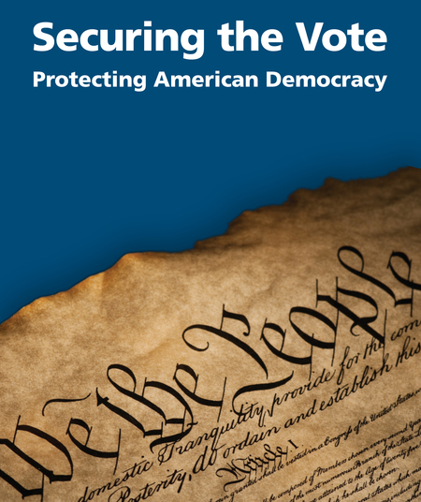
Election Security and Integrity.
How can you be sure your vote is safe and secure?
Registration and Voting
- The Florida Division of Elections checks each voter registration application to verify the applicant’s identity and works with other agencies to identify deceased voters and ineligible felons.
- Each of the 67 Florida counties maintain their own voter database, terminating a single point entry to the systems.
- Voters must show photo and signature identification to vote. Vote by Mail Ballots must be signed, and the signature is verified by trained office staff.
- Vote by Mail signatures in question are reviewed and can only be rejected by the Canvassing Board, during public meetings. Voters have two days after the election to correct a missing or mismatched signature by returning the affidavit and proper identification confirming it is their ballot.
- Voters can vote provisional ballots if there is any question about their eligibility. This ensures everyone has a chance to use their right to vote.
Tabulation and Tampering
- Our state certified equipment is tested before each election with a public logic and accuracy test to make sure the machines are counting votes correctly. To do this, we produce a test deck of predetermined random results to be tabulated in a sample group of optical scanners to ensure quality assurance.
- Ballot equipment and ballots themselves are under 24-hour camera surveillance and stored in areas with badge access until they are deployed for voting.
- The voter registration system and the tabulation system are not connected to each other. A stand-alone elections management server that is not connected to the internet is used to tabulate and report results.
- Office software patches and updates are installed regularly. Cyber hygiene procedures are in place which include network testing and monitoring.
- Election results from each ballot scanner are encrypted and backed up by paper result tapes. These tapes are then posted on the doors of each polling location and driven to our central office located in downtown Sebring. These tapes are double checked against the initial results.
- Once the election has ended, the voted ballots are stored in a secure room for 22 months and can be rescanned if there is any problem or questions about the results.
- Every Florida county conducts a manual or electronic post-election audit.

Meet
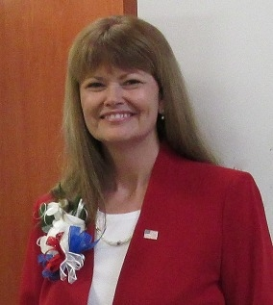
Supervisor of Elections, The Honorable Karen Healy
Karen was hired as the Deputy Supervisor for the Honorable Joe Campbell in 2003. She quickly learned GIS mapping, Ballot and Web design, and became familiar with the candidate qualifying process. Later, in 2011, she received the title of Assistant Supervisor. After Supervisor Campbell’s retirement, Karen acquired more administrative rolls and obtained her MFCEP with the Honorable Penny Ogg. After Penny’s death in 2021, Governor Ron DeSantis appointed Karen as Supervisor. She loves serving the residents of Highlands County and considers Sebring her home. Karen is committed to fair, honest, accurate, and secure elections for the voters of Highlands County.
Deputy Supervisor, Giselle Acevedo
Giselle has worked in the Supervisor of Elections office twenty years this past October. She started as the receptionist but quickly became your trusted Vote by Mail Coordinator while working under previous Supervisor, Joe Campbell. Along the way she has picked up a few more hats such as Voter Outreach Coordinator and Records Management Liaison Officer. Giselle’s favorite part of her job is attending voter outreach to educate and interact with the public.

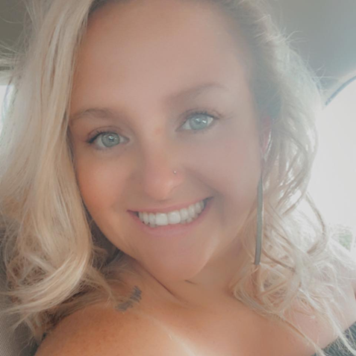
Deputy Supervisor, Cortni Mays
Cortni has worked for the Elections Office since October of 2019. During her two and a half years she has been the friendly face at the lobby counter. As full-time receptionist, she ensures professional and well-disposed customer service, and voter registration – processes new voters, updates voting records, and assists with list maintenance. Cortni is very creative and enjoys learning about history. You can see her passion blossom within the office decorations and our booth she helped facilitate in the County’s Centennial Celebration in 2021. Her favorite part of her job is being able to interact with and educate the residents of Highlands County.
Meet

Operations Manager, Dan Blowers
Dan started at the Election’s Office in January 2015. He began as the Voting Equipment Technician. He learned how to maintain voting equipment and update programs for each election, as well as preventive maintenance. In July of 2017, Dan was promoted to Operations Manager which allows him to maintain equipment and manage distribution of equipment to each precinct. His favorite part of his job is making a difference in the election process for the voters of Highlands County.
Election Worker Manager, Debbie Schoonover
Debbie began serving the voters of Highlands County in 2006 as a temporary worker during elections to help process applications. In 2013, she was hired on as a full-time receptionist. In late summer of 2019, she was promoted to your much-loved Election Worker Manager. This change of pace allows Debbie to recruit and train poll workers and oversee election operations from beginning to end. She loves being able to work with the poll workers. She is so grateful for their assistance in the elections, as the workers help ensure each election proceeds smoothly and successfully year after year. Debbie also loves being behind the scenes during each election as it is an ever-changing adventure.
Deputy Supervisor, Andrew Fields
Andrew is a new member of the team. He started January 2022. We learned fast that he likes being able to wear a few hats for the office. During election time you can find him learning about the warehouse operations with Dan. In office, he processes payroll and conducts accounts payable and receivable. So far, his favorite part about his job is the wonderful people he works with daily. We are also so happy he is part of the team too. (Especially on payday!)

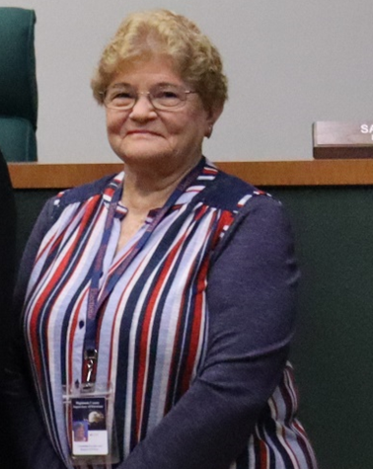
Deputy Supervisor, Betty Milam
You may know Ms. Betty from the Sherriff’s office before she retired. However, seven years ago, she came to work for the Elections Office under the Honorable Penny Ogg. Betty is the part time receptionist, assisting Cortni in Voter Registration, record updates and customer service. Her high points are her wonderful co-workers and being able to interact with the friends she is able to help each day. She also appreciates learning about laws and regulations and our computer systems.

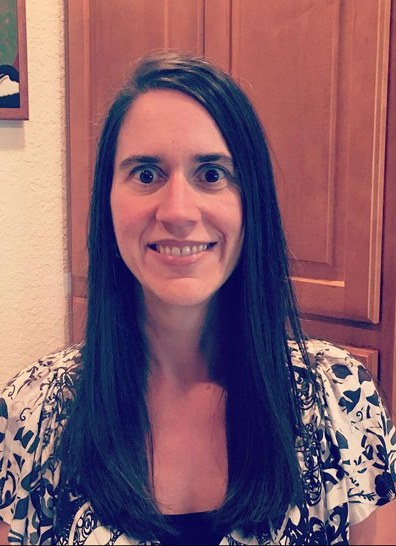
Deputy Supervisor, Lisa Branca
Lisa joined the Elections Office in January 2022, but she is no stranger to public service. She has been a proud public servant in Highlands County for over 22 years. She has earned three Awards of Financial Reporting Achievement from the Government Finance Officers Association (GFOA) and the designation of Certified Government Financial Manager (CGFM) and is able to assist Karen with grants, benefits and the budget. Lisa is looking forward to learning new tasks to expand her knowledge base into all facets of the election process so that she can better serve the constituents of Highlands County. Her favorite part of her job is the interactions with her team and taking on new, different responsibilities.

The Highlands County Supervisor of Elections
580 South Commerce Avenue, Room A201
Sebring, Florida 33870
(863) 402-6655
www.Votehighlands.com

